WEB TECHNOLOGY(LAB-8)

Name:- Anusthan Singh (20051337) Cse-9

Q1. 1. Illustrate the usage of abstract class with following Java classes – i>An abstract class „student‟ with data member roll no, reg no and a abstract method course() ii>A subclass "kiitian‟ with course() method implementation

Code:-

import java.util.Scanner;

abstract class student {

    int rollno, rgno;

    abstract void course();

}

class kiitian extends student {

    Scanner sc = new Scanner(System.in);

    void course() {

        System.out.println("INPUT THE DATA FOR STUDENT");

        System.out.println("ENTER THE REGISTRATION NUMBER OF STUDENT");

        rgno = sc.nextInt();

        System.out.println("ENTER THE ROLL NUMBER OF STUDENT");

        rollno = sc.nextInt();

    }

    void display() {

        System.out.println("THE ROLL NO AND REGISTRATION NUMBER OF THE STUDENT IS\n" + rgno + "\n" + rollno);

    }

}

public class q1 {

    public static void main(String[] args) {

        kiitian Kiit = new kiitian();

        Kiit.course();

        Kiit.display();

    }

}

Output:-

INPUT THE DATA FOR STUDENT

ENTER THE REGISTRATION NUMBER OF STUDENT

13245677

ENTER THE ROLL NUMBER OF STUDENT

20051337

THE ROLL NO AND REGISTRATION NUMBER OF THE STUDENT IS

13245677

20051337

Screenshot:-

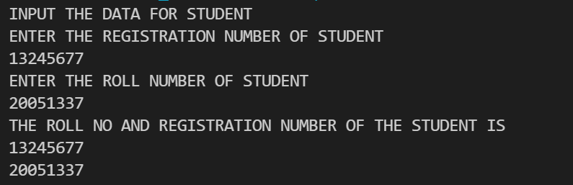

2. Define an interface Motor with a data member –capacity and two methods such as run() and consume(). Define a Java class „Washing machine‟ which implements this interface and write the code to check the value of the interface data member thru an object of the class.

Code:-

interface motor {

    int capacity = 200;

    void run();

    void consume();

}

class q2 implements motor {

    public void run() {

        System.out.println("It's running Sucessfully");

    }

    public void consume() {

        System.out.println("It also consume low current");

    }

    public static void main(String args[]) {

        motor obj = new q2();

        obj.run();

        obj.consume();

    }

}

Output:-

It's running Sucessfully

It also consume low current

Screenshot:-



3. Define an interface with three methods – earnings(), deductions() and bonus() and define a Java class „Manager‟ which uses this interface without implementing bonus() method. Also define another Java class „Sub staff‟ which extends from „Manager‟ class and implements bonus() method. Write the complete program to find out earnings, deduction and bonus of a sub staff with basic salary amount entered by the user as per the following guidelines – earnings basic + DA (80% of basic) + HRA (15% of basic)deduction PF 12% of basic ,bonus 50% of basic.

Code:-

import  java.util.Scanner;

interface salary

{

   public  void  earnings();

   public  void  charges_deduction();

   public  void  bonus();

}

abstract  class  Manager  implements  salary

{

  double  earning,deduction;

  public  void  earnings()

 {

   System.out.println("Manager  implements  the  method of earnings.");

 }

 public  void  charges_deduction()

 {

  System.out.println("Manager  implemnets  the  method of  deductions.");

 }

}

class  Substaff  extends  Manager  implements  salary

{

  double  b_salary,bonus;

  Substaff(int bs)

  {

    b_salary=bs;

  }

  public  void  calculate()

  {

     earning=b_salary+(0.8*b_salary)+(0.15*b_salary);

     deduction=0.12*b_salary;

     bonus=0.5*b_salary;

  }

  public  void  bonus()

  {

     System.out.println("Substaff  implementing  the  method  bonus.");

  }

  public  void  display()

  {

    System.out.println("Earning  of  the  employee  :  "+earning);

    System.out.println("Deduction  of  the  employee  :  "+deduction);

    System.out.println("Bonus  of  the  employee  :  "+bonus);

  }

}

public  class  q3

{

  public  static  void  main(String args[])

  {

     Scanner  sc=new  Scanner(System.in);

     int  a;

     System.out.println("Enter  the  basic  salary:-");

     a=sc.nextInt();

     Substaff  st=new  Substaff(a);

     st.calculate();

     st.bonus();

     st.display();

   }

}

Output:-

Enter the basic salary:-

100000

Substaff implementing the method bonus.

Earning of the employee : 195000.0

Deduction of the employee : 12000.0

Bonus of the employee : 50000.0

Screenshot:-

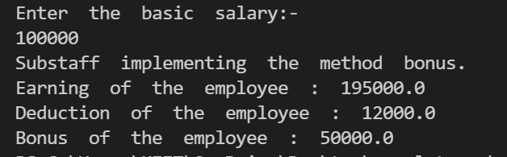

By:- Anusthan Singh (20051337) Cse-9